**BookMyShow:**

**Component Segregation:-**

1. Header.
2. Navbar tabs.
3. Carousel slider.
4. Recommended movies .
5. Movie card in the recommended movies.
6. Stream is a component.  
   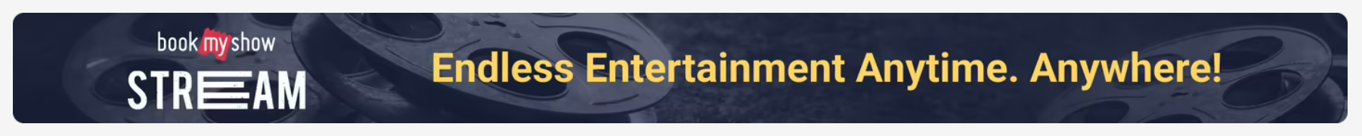
7. Live events.  
   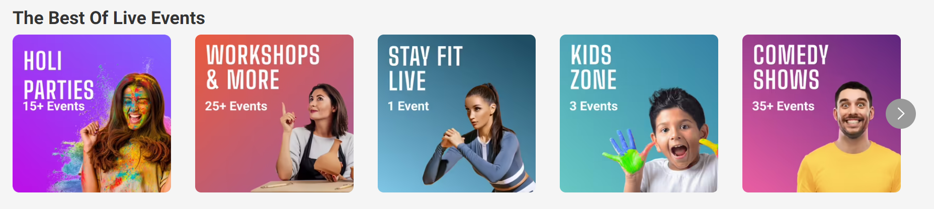
8. Eac card in the live events.
9. Premium movies.  
   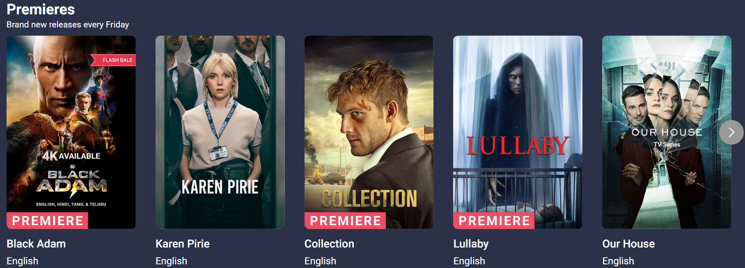
10. Each card in the premium movies.
11. Events near you.  
    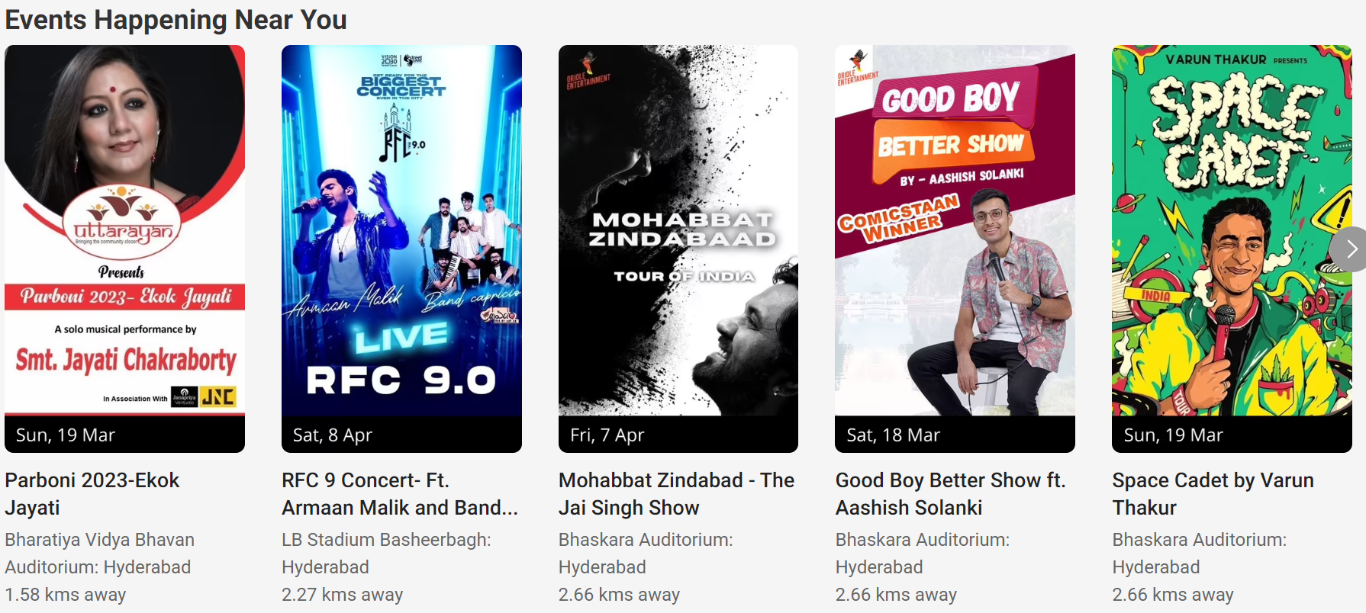
12. Each card in the events near you.
13. Online streaming events.  
    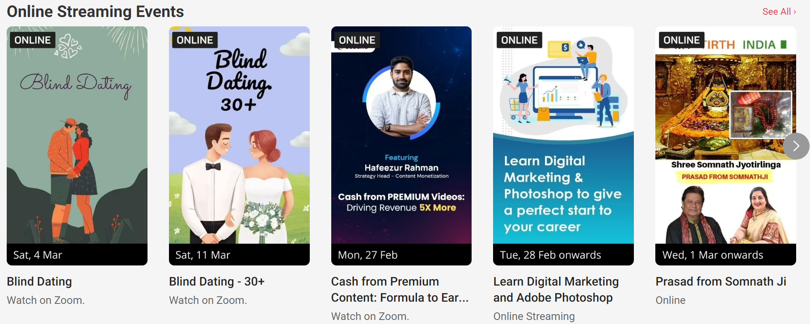
14. Outdoor events.  
    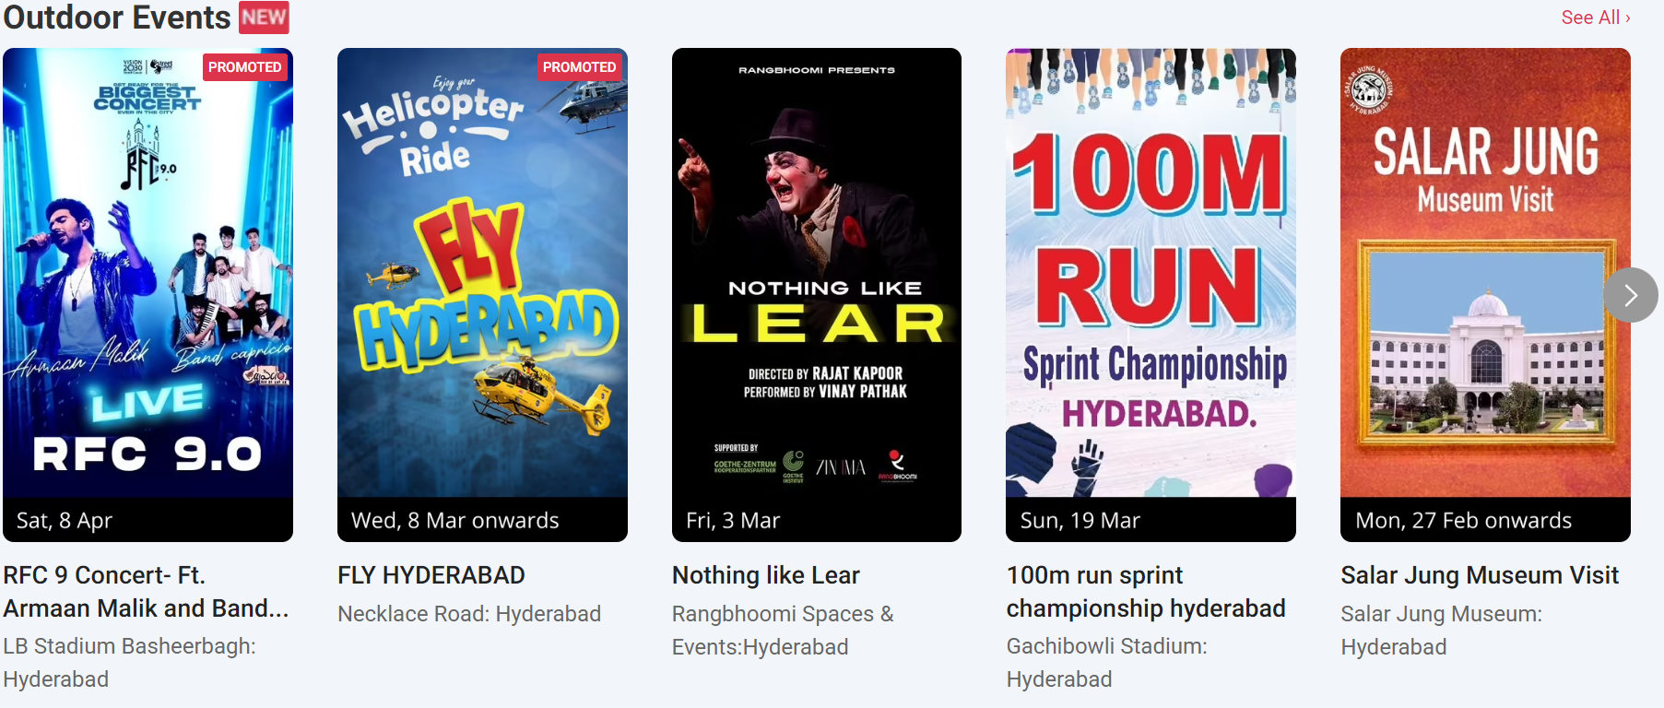
15. Laughter therapy.  
    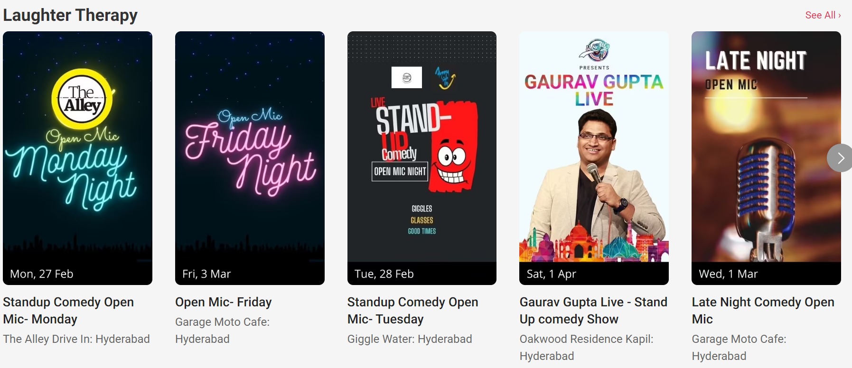
16. Popular events.  
    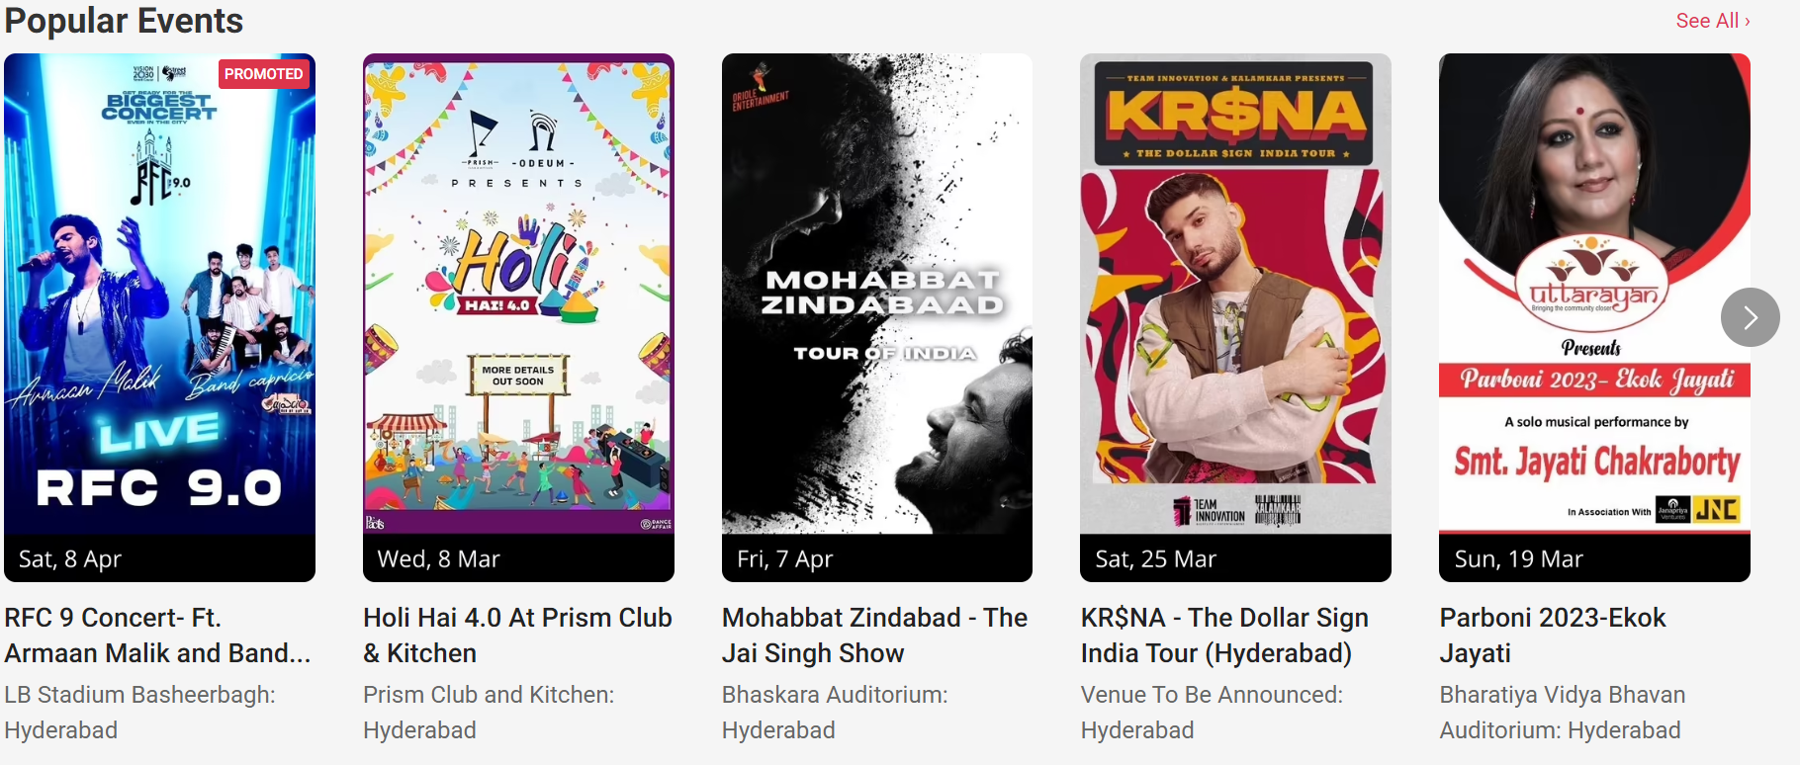
17. The latest play.
18. 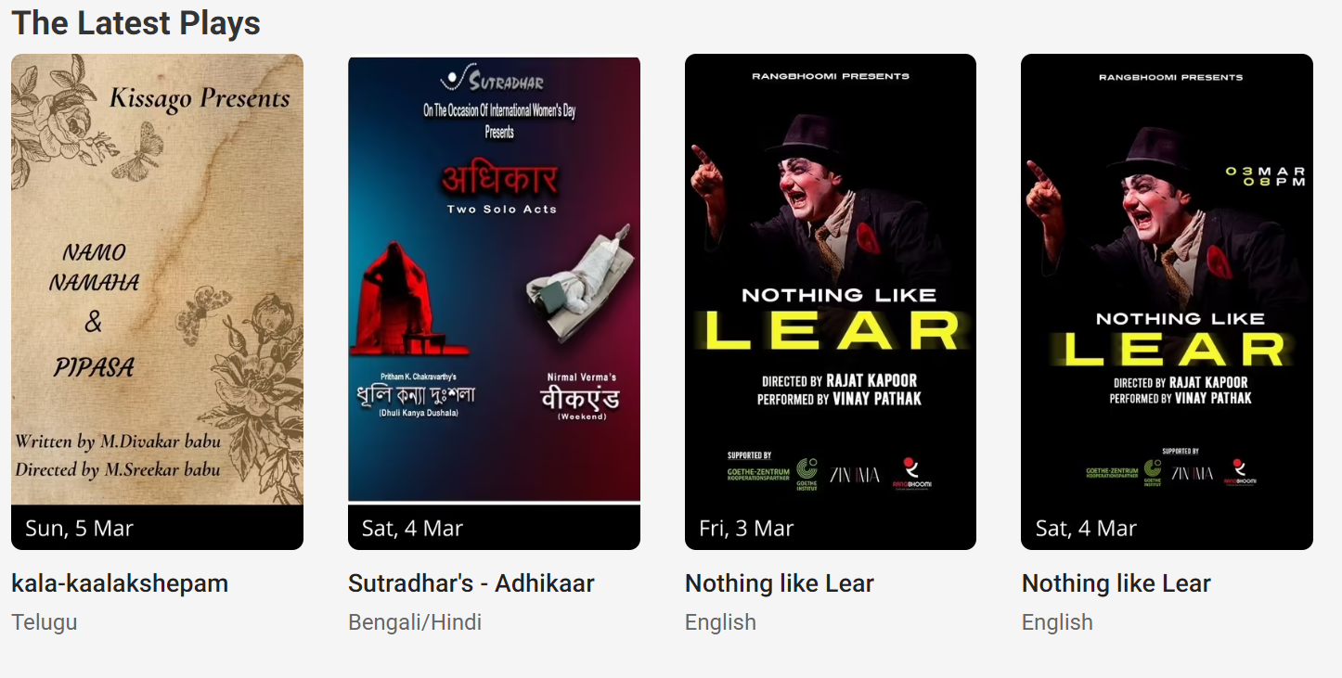
19. Top games.  
    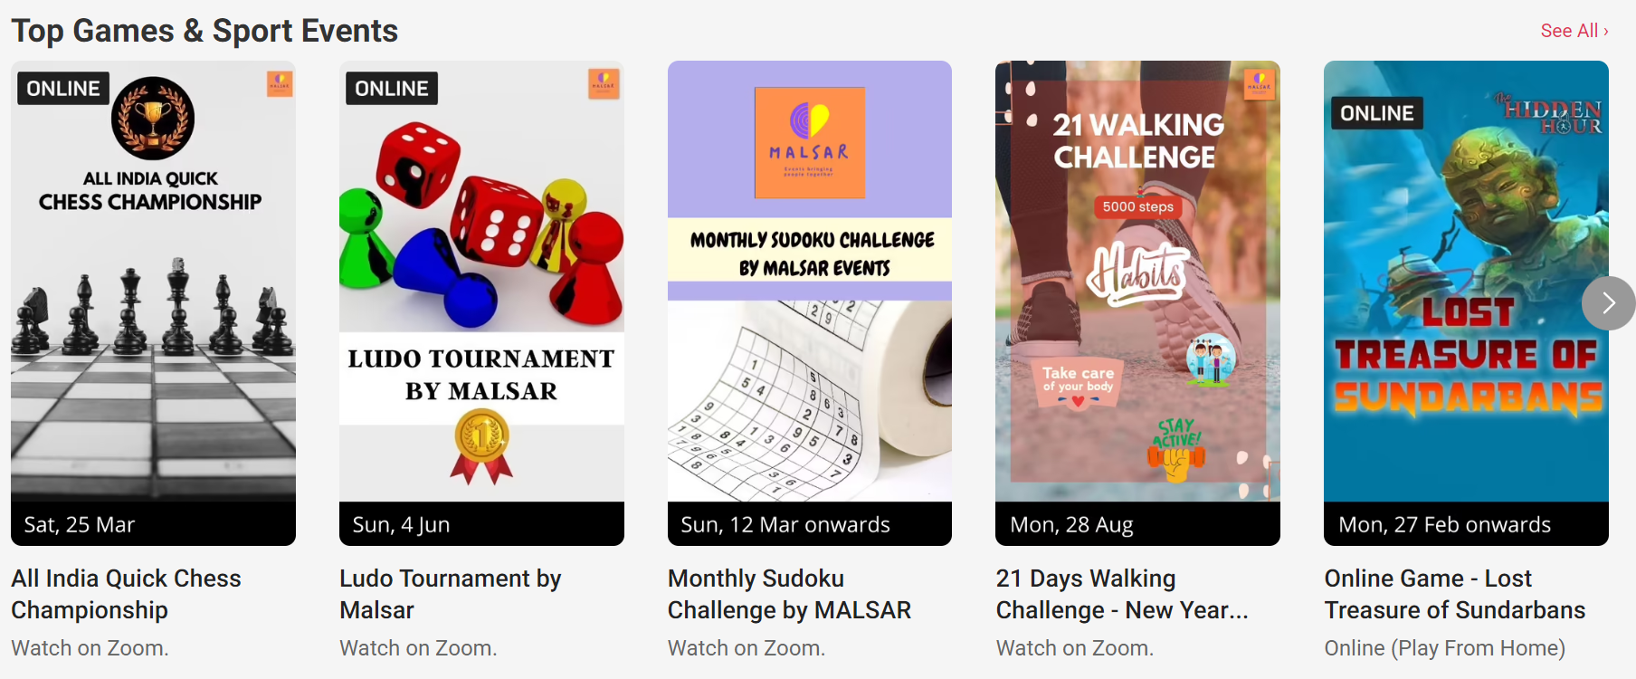
20. Trending right now.  
    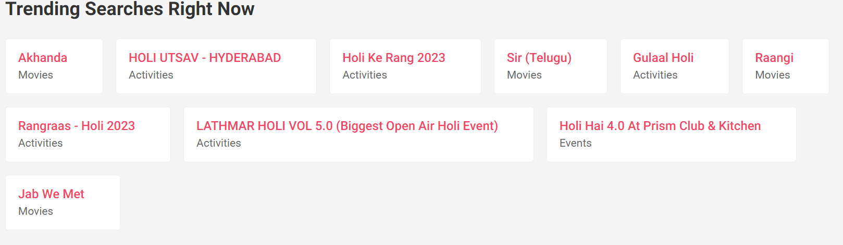
21. Each card in trending right now component.
22. Explore fun activities.  
    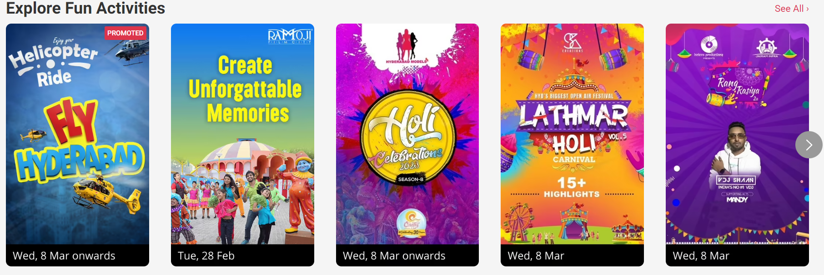

All the components from 11 can be used as common components except 20 and 21